**Web Interface of Stock Prediction**

Step 1: first install the required libraries presented in ‘requirements.txt’ in Stock Prediction Web Interface in your IDE( i.e. PyCharm or VScode)

Step 2: Now open all three files( 1. Stock.py, 2. Form.html, 3. Plot.html) in your Ide and run ‘Stock.py’ in your Ide

Step 3: After running ‘stock.py’ we can get the following output in terminal

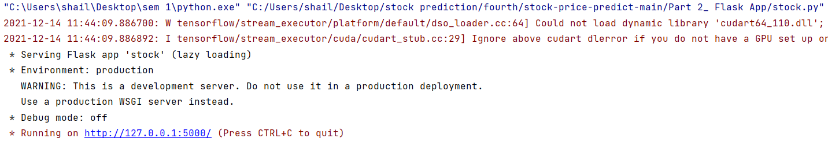

Now click on link “ <http://127.0.0.1:5000/> ” or copy the link in your browser to open the Web Interface of Stock Prediction

Step 4: Now, Enter the valid stock symbol in “Stock Name” for which you want to predict the stock price. And Also enter days in “Ahead” to get prediction of stock price for No. of days ahead ( Note. Less the no. of days ahead, more accurate will be the prediction)

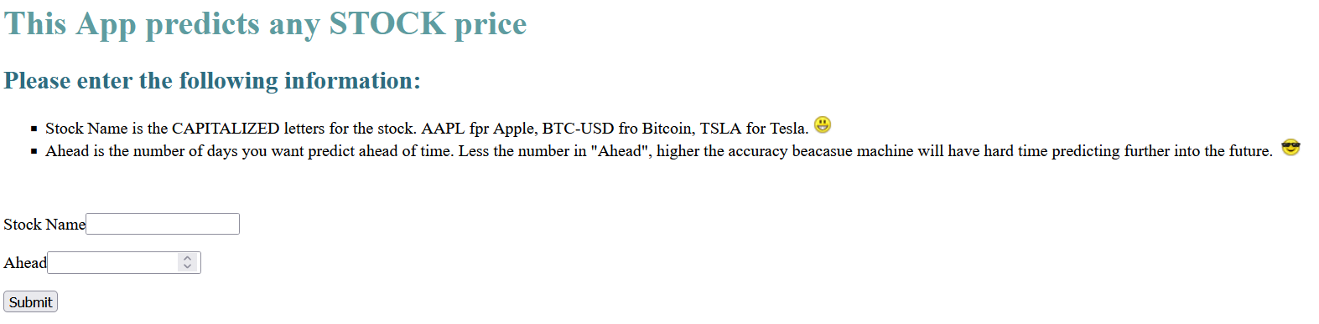Step 5: After submitting the stock symbol the web page will take some time to predict and the it displays the next page with stock prediction

